**Software Requirements Specification**

**for**

*Clarify : A Cross Platform Community Based Application To Resolve Real Time Queries.*

**Version 1.0 approved**

**Prepared by**

**Chinmay Chitale**

**Chinmay Patankar**

**Prathamesh Ratolikar**

**Sudershan Shivjatak**

**BRACT’s Vishwakarma Institute of Information Technology**

**18th Sept ‘18**

**Table of Contents**

**Table of Contents ii**

**Revision History ii**

**1. Introduction 4**

1.1 Purpose 4

1.2 Intended Audience and Reading Suggestions 4

1.3 Product Scope 4

1.4 References 5

**2. Overall Description 5**

2.1 Product Perspective 5

2.2 Product Functions 6

2.3 User Classes and Characteristics 7

2.4 Operating Environment 8

2.5 Design and Implementation Constraints 8

2.6 User Documentation 9

2.7 Assumptions and Dependencies 9

**3. External Interface Requirements 9**

3.1 User Interfaces 9

3.2 Hardware Interfaces 10

3.3 Software Interfaces 11

3.4 Communications Interfaces 11

**4. System Features 11**

4.1 System Feature 1 11

4.2 System Feature 2 (and so on) 12

**5. Other Nonfunctional Requirements 12**

5.1 Performance Requirements 12

5.2 Safety Requirements 12

5.3 Security Requirements 12

5.4 Software Quality Attributes 12

**6. Other Requirements 12**

**Revision History**

|  |  |  |  |
| --- | --- | --- | --- |
| **Name** | **Date** | **Reason For Changes** | **Version** |
|  |  |  |  |
|  |  |  |  |

# **Introduction**

The introduction of the Software Requirements Specification (SRS) provides an overview of the entire SRS with purpose, scope, definitions, acronyms, abbreviations, references and overview of the SRS. The aim of this document is to gather and analyze and give an in-depth insight of the complete **student-teacher based interactive learning system** by defining the problem statement in detail. Nevertheless, it also concentrates on the capabilities required by stakeholders and their needs while defining high-level product features. The detailed requirements of the **student-teacher based interactive learning system** are provided in this document.

## **Purpose**

The purpose of this document is to collect and analyze all assorted ideas that have come up to define the system, its requirement with respect to customers. Also we shall predict how the product is being used in the market and how it will benefit different communities in various possible ways. In short the purpose of this document is to summarize the concepts and detailed overview of our software product ,its parameters and goals.

This document describes the project's target audience and its user interface, hardware and software requirements. It defines how our client, team of experts and other audience see the product and its functionality. This document will also debrief the development phase and various scheduled processes ahead .

## **Intended Audience and Reading Suggestions**

The Document is subjected and limited to the developers, testers , stakeholders, marketing staff, users and its writers. This Document will further walk reader through various requirement topics which covers scope of the product ,references, general overview, user and hardware requirements followed with functionalities and with some safety requirements. In general this document is purely intended to make user understand the general idea of this product and its benefits and the some other guidelines are covered.

## **Product Scope**

Our software, a cross platform application for student teacher community which will resolve query of the customers in a tailor suited way. The basic aim of this software is to benefit the student community by resolving their queries in a stipulated time. This software will also benefit the experts community who will be aboard with us as they can solve challenging questions everyday and will be rewarded accordingly. A full proof business strategy is designed to escalate business with the experts community with ease.

## **References**

* *<https://docs.microsoft.com/en-us/xamarin/>*

* *<https://docs.microsoft.com/en-us/azure/>*

* *<https://docs.microsoft.com/en-us/visualstudio/?view=vs-2017>*

* *<https://en.m.wikipedia.org/wiki/Agile_software_development>*

* *<https://www.projectinsight.net/project-management-basics/basic-project-management-phases>*

* *<https://blogs.msdn.microsoft.com/microsoft_press/2016/09/01/free-ebook-microsoft-azure-essentials-fundamentals-of-azure-second-edition/>*

* *<https://sendgrid.com/docs/index.html>*

* *<https://www.codeproject.com/Articles/4416/Beginners-guide-to-accessing-SQL-Server-through-C>*

* *<https://m.youtube.com/watch?v=1EpYqtSlOr8>*

* *<https://www.c-sharpcorner.com/ebooks/azure-web-apps-for-developers>*

* *<https://www.c-sharpcorner.com/ebooks/xamarin-forms-for-beginners>*

* [*https://www.c-sharpcorner.com/ebooks/beginning-c-sharp-object-oriented-programming*](https://www.c-sharpcorner.com/ebooks/beginning-c-sharp-object-oriented-programming)

# **Overall Description**

## **Product Perspective**

The perspective of the product is basically to change the way online learning platforms currently are and make it more user friendly and interactive. This basically is a self-contained tailor suited product which will on demand provide solutions to the clients in a telegenic way. It is a simple mechanism with a client server based methodology to share and acquire knowledge.

## **Product Functions**

The main features of this product could be briefed as follows:-

* Cross Platform:Basic set of features which will be runnable on every platform and advanced set of platform specific features for enhancing user experience.

* Cloud Services:-Azure by Microsoft cloud services are being used as our support system which will handle all database related issues and other server issues.

* Backend services:-Backend dependencies for the software such as

1)SendGrid: Mailing service for verifying legitimate users for the software.

2)CRON: To schedule jobs to run periodically at fixed times, dates, or intervals.

## **User Classes and Characteristics**

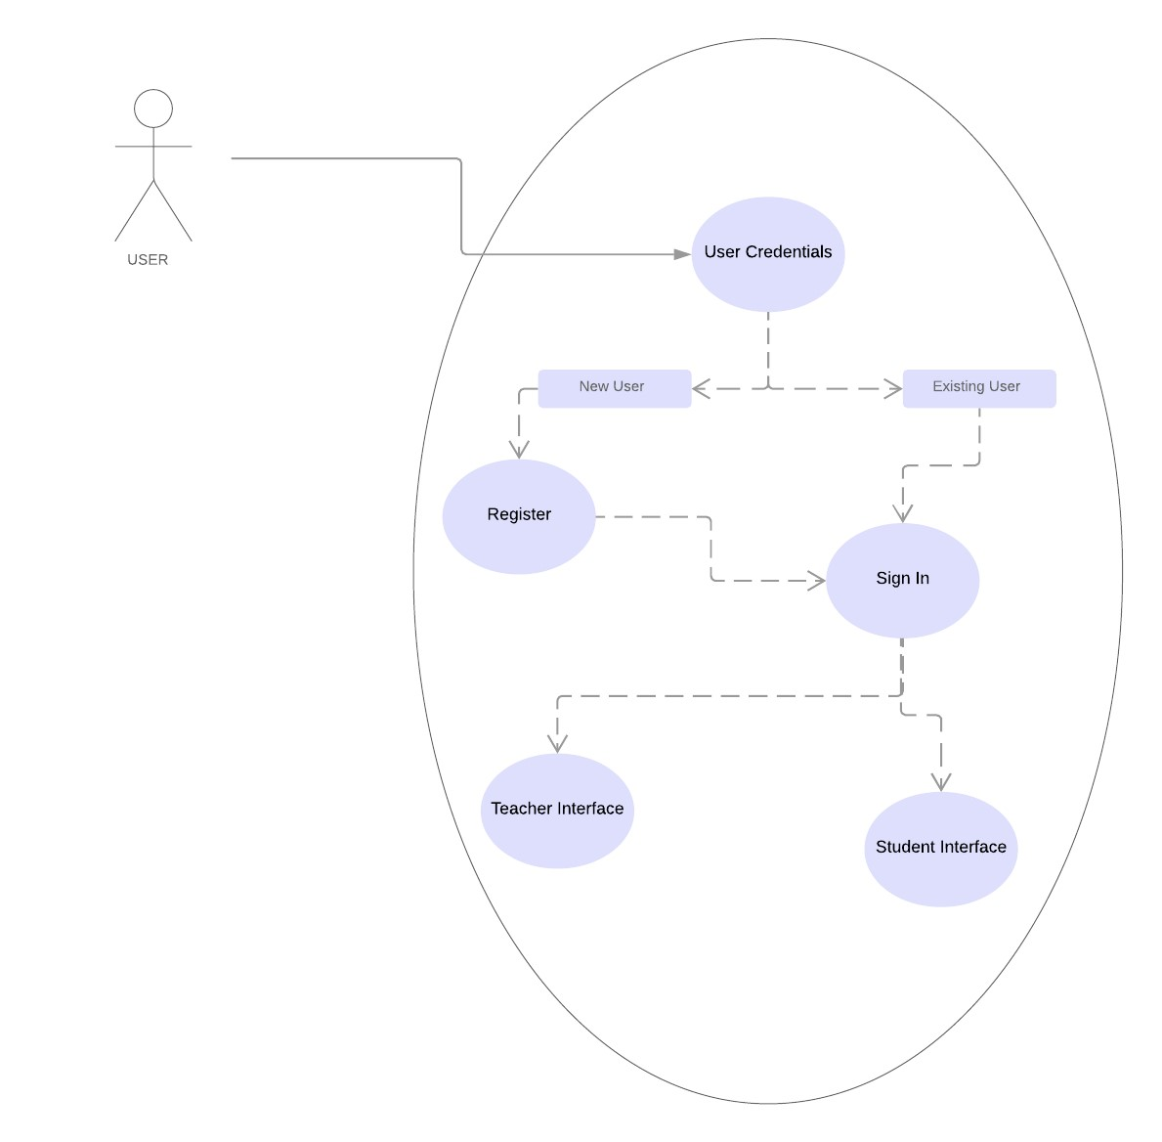

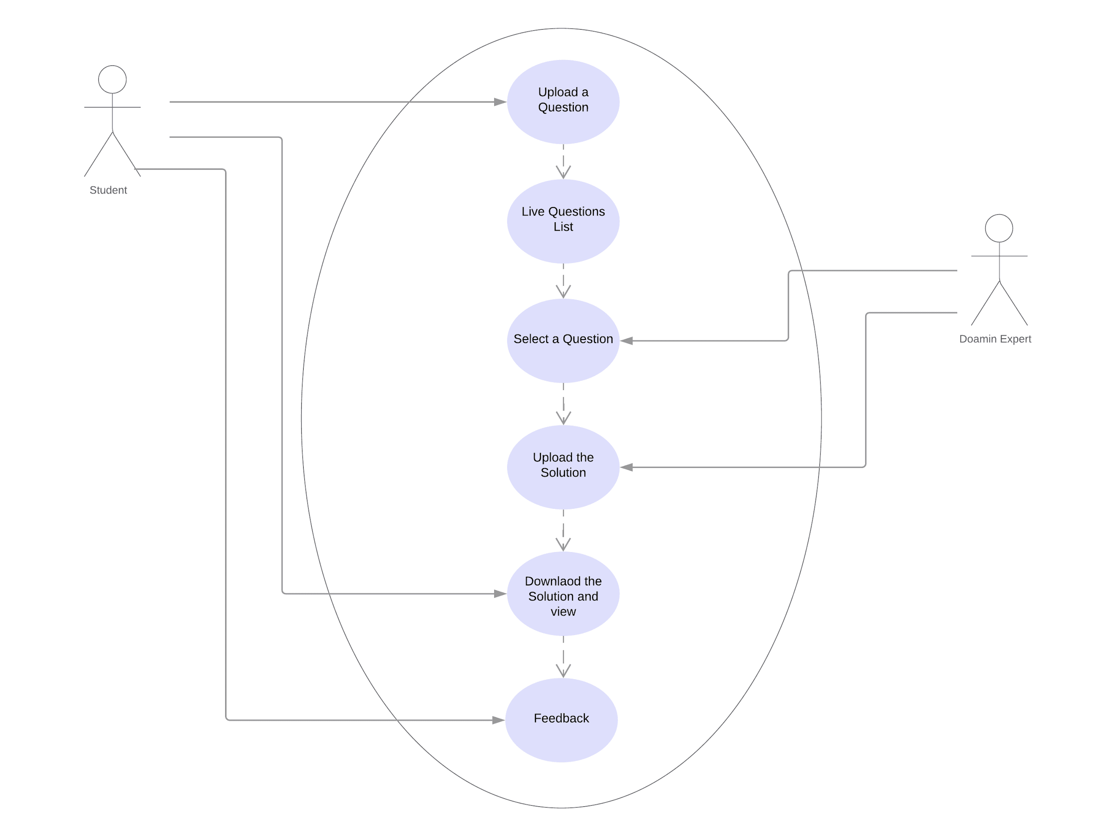

**Scenarios**

**Student Functional Interface:**

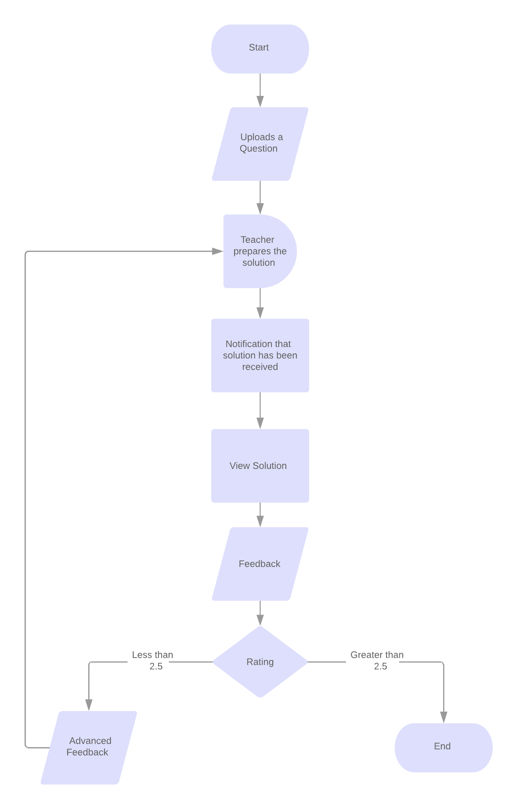**Scenario Details:**

Student Functional Interface gives the perspective of how the student will use the application on his/her device and what functions he/she has to perform in order to utilize the benefits of the applications.The Student Functional interface flowchart shows the flow of processes on the student application starting from firing a query/Uploading a question till the satisfactory feedback of the student.

**Teacher Functional Interface:**

1. **Scenario Details:**

Teacher Functional Interface gives the perspective of how the teacher will use the application on his/her device and what functions he/she has to perform in order to solve the queries.The Teacher Functional interface flowchart shows the flow of processes on the teacher application starting from viewing the live question list to receiving a satisfactory feedback.

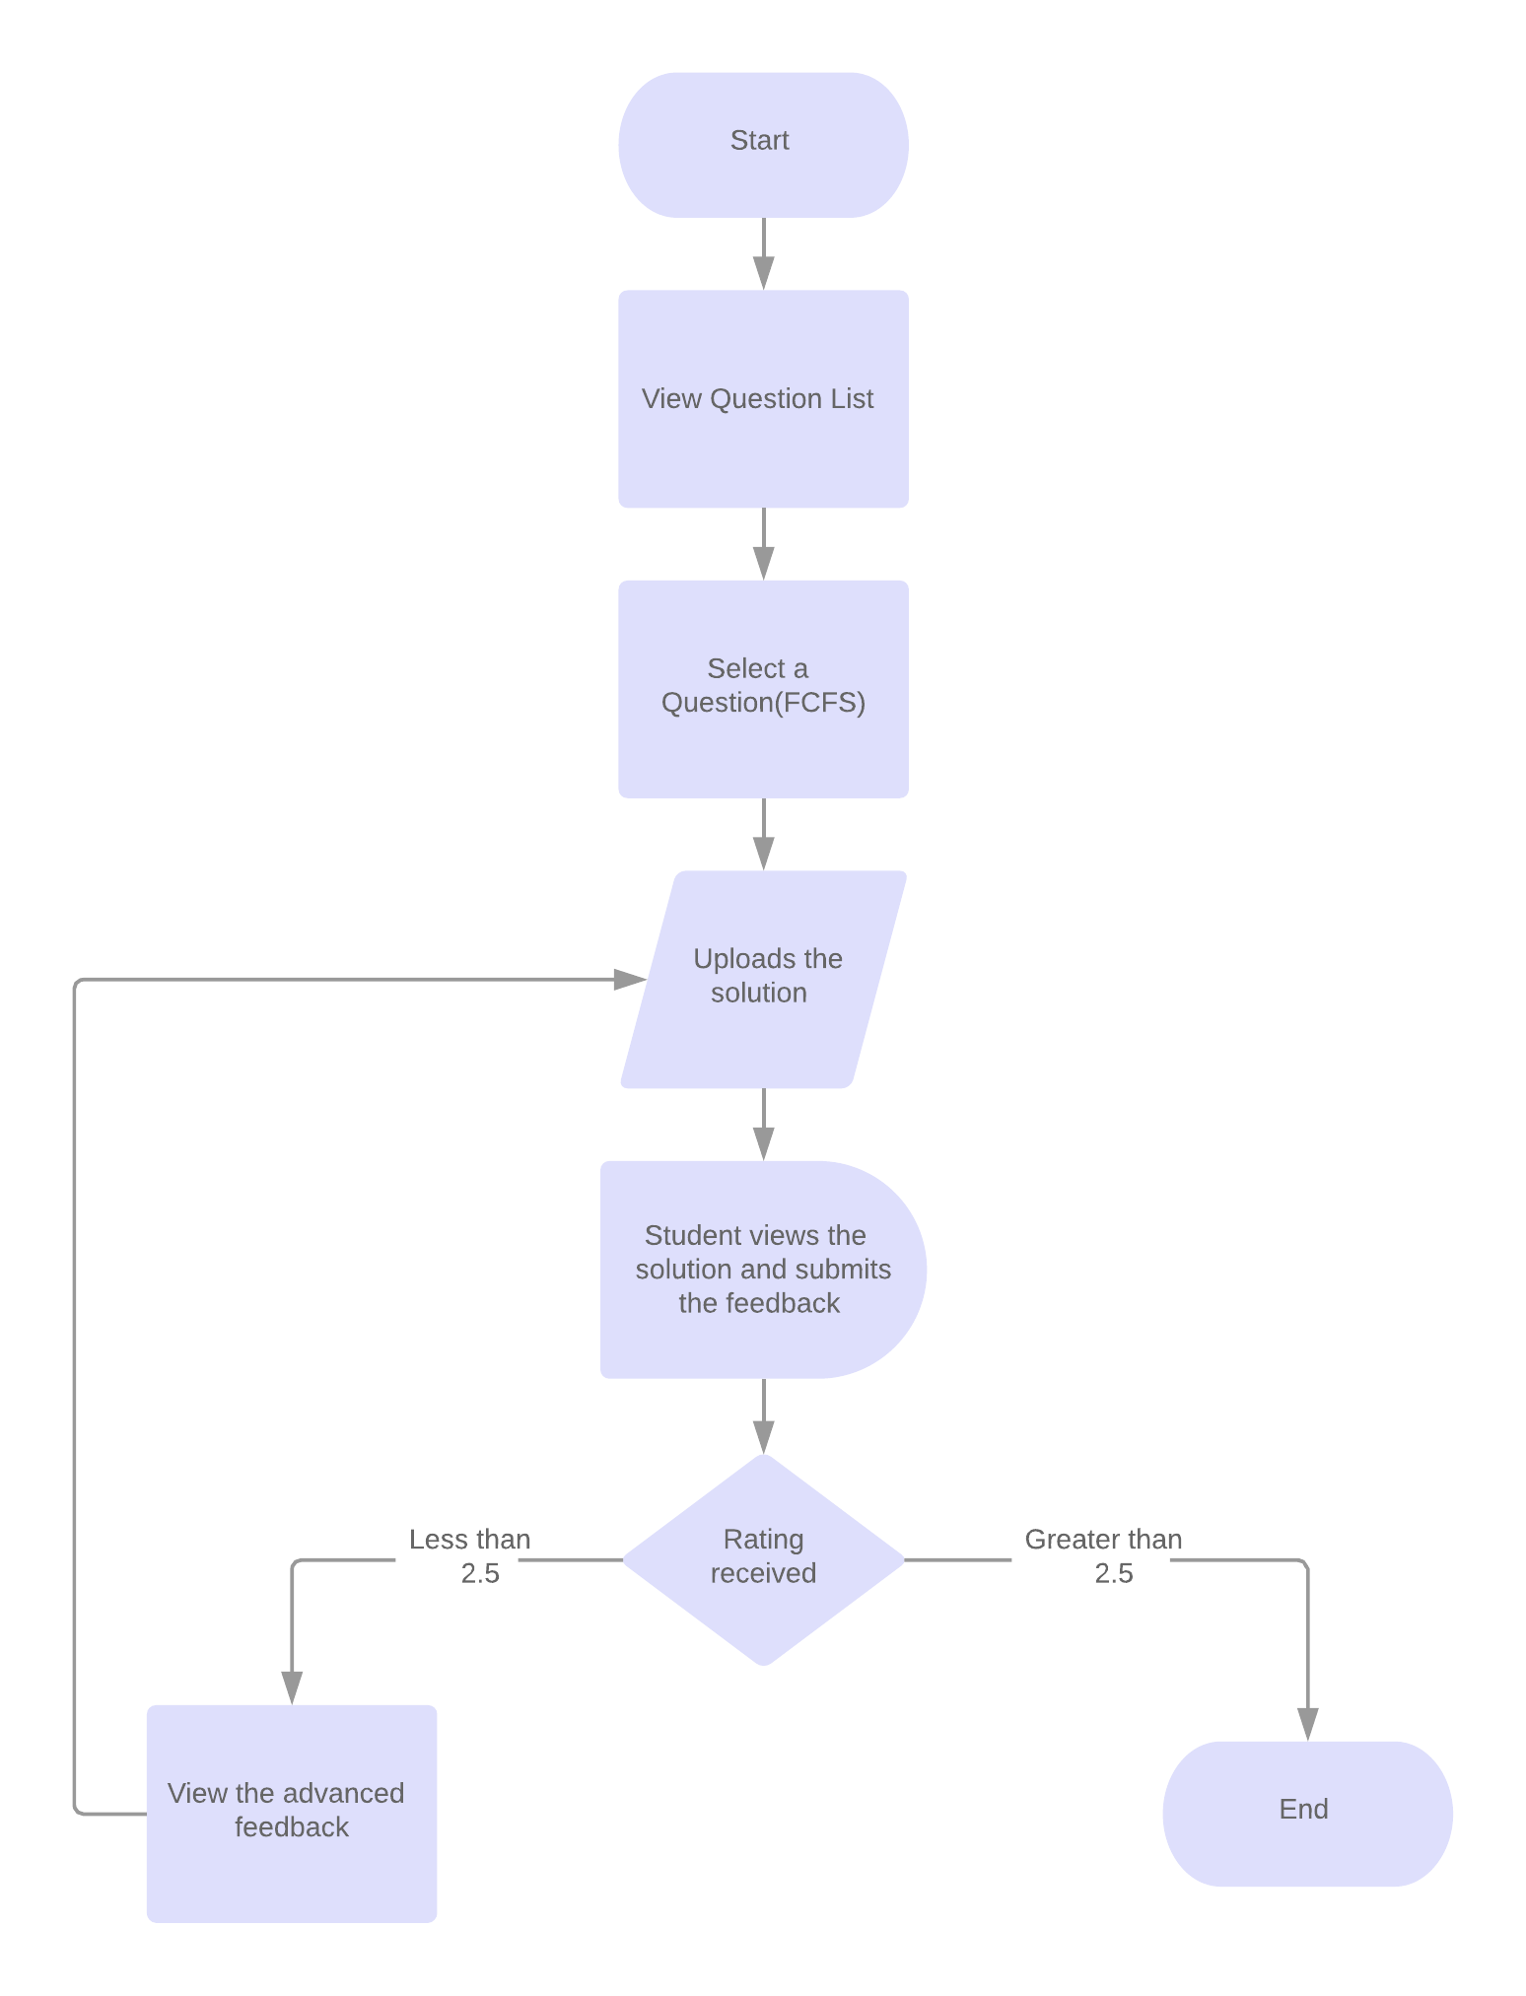

1. **Open Issues: Two types of issues yet to be resolved:-**

* Multiple Teachers single student.

* Unsatisfactory Ratings/Feedback for teacher.
* Listener Service for Notification.

## **Operating Environment**

* Android Minimum API Version 5.0.2 or higher.
* Windows 10 Build 15.0.3 or higher.
* Windows 8.1 / Windows Phone 8.1 WinRT/Windows 10 build(1503 or higher).
* iOS 8 or higher.

## **Design and Implementation Constraints**

The platform is supposed to be built in Xamarin base cross platform framework which is highly flexible and cost effective. There will be use of some other backend services such as Azure cloud services by Microsoft and some security services like SendGrid. Constraints such as failure in firebase services may cause security issues which can be rectified by direct social media or email address based login. Hardware issues such as memory constraints can be rectified by Azure Scalability feature which will handle the load of the traffic on the server. To overcome security constraints SendGrid will provide email verification for the clients.

## **User Documentation**

*<List the user documentation components (such as user manuals, online help, and tutorials) that will be delivered along with the software. Identify any known user documentation delivery formats or standards.>*

## **Assumptions and Dependencies**

This software is highly dependent on the application and user interfaces ,so it is assumed that the user is familiar with the use of mobile devices and the applications on it. Some more dependencies of third party applications such as Azure Cloud Services and SendGrid is also to be considered.

# **External Interface Requirements**

## **User Interfaces**

1. *Main Page -* 
   1. *Sign In Button.*
   2. *Sign Up Button.*
   3. *Menu Button.*
2. *Menu -*
   1. *Button -*
      1. *Sign In.*
      2. *Sign Up*
      3. *Dashboard.*
      4. *Ask Question.*
      5. *About Us.*
      6. *Answer.*

1. *Sign Up Page -*
   1. *Text Fields -*
      1. *Email id.*
      2. *Name.*
      3. *Surname.*
      4. *Mobile Number.*
      5. *Course.*
      6. *Major.*
      7. *Password.*
      8. *Confirm password.*
   2. *Check Boxes.*
      1. *Student.*
      2. *Teacher.*
   3. *Button.*
      1. *Sign up.*
2. *Sign In Page*
   1. *Text Fields -*
      1. *Email Id.*
      2. *Password.*
   2. *Check Box.*
      1. *Student.*
      2. *Teacher.*
   3. *Button -*
      1. *Sign In.*
3. *Dashboard.*
   1. *Button -*
      1. *Personal Profile.*
      2. *List of Questions.*
      3. *Your Videos.*
      4. *History.*
      5. *Subscription.*
      6. *Feedback.*
4. *Question Page -*
   1. *Text Field -*
      1. *Question .*
   2. *Buton -*
5. *About Us -*
   1. *Web View.*
6. *Answer Page.*
   1. *Text Field.*
      1. *Answer Text.*
   2. *Button.*
      1. *File chooser.*
      2. *Submit.*

## **Hardware Interfaces**

*Supported Devices -*

1. *Android Devices with API level 5.0 or higher.*
2. *Windows devices with windows 10 build 1503 or higher.*
3. *Ios Devices with Ios 8 or higher.*

## **Software Interfaces**

*Following are the connected components in the system.*

1. *Microsoft Azure.*
2. *Sendgrid Mail system.*
3. *Sql database.*
4. *Sqlite database.*
5. *Sql Server.*

## **Communications Interfaces**

1. *http connection for loading a webview.*
2. *http connection for accessing api.*
3. *Tcp/Ip connection for connecting to the database.*

## Technical Specification

1. Performance Constraint
   1. Supports 10 Concurrent database connections.
   2. Storage space limit is of 250 Gb.
   3. Verification Emails can be sent 40000 per month.
   4. Only one server instance.
   5. Currently database speed is 10 DTU which can be extended upto 3000 DTU.
2. Hardware Specification
   1. Android api level 5.0 or higher.
   2. Ios 8 or higher.
   3. Windows 10 (build 1503) or higher.
3. Memory specification.
   1. Requires 1 Gb ram to run properly.

# **System Features**

## Accept Questions.

1. *User clicks on ‘Ask Question Button’ due to which he/she will be redirected to the Questions page.*
2. *User types the question/ uploads an image corresponding to his/her question.*
3. *The application submits the question with its domain to the server.*

* 4.1.3 Functional Requirements

*REQ 1 - The application should be connected with the internet.*

## Provide Solution

1. *The Teacher/Expert receives a notification notifying him about a question matching his domain.*
2. *The teacher/Expert selects the question and he/she will be redirected to the answer page.*
3. *teacher/Expert can answer in text format by typing or select a video/audio/ppt/text file from the file system.*
4. *on clicking submit button the solution is uploaded to the server from where it will be forwarded to the user who asked it.*

*Functional Requirement*

*REQ 1 - The Application should be connected to the internet.*

*REQ 2 - The application should have access to the file storage.*

# **Other Nonfunctional Requirements**

## **Performance Requirements**

* Data transfer between server and client should be completed in minimum amount of time.
* Transactions should be done in a secure session and should be done within seconds.
* The product should run in every operating system seamlessly.
* The product should run every hardware device seamlessly.

## **Safety Requirements**

* Domain Experts should not reveal their password and id. This may cause a problem to the student who is asking a question as he will be provided with incorrect information leading to degrading the quality and standards of the service and domain experts. Users should their take preventive measures so that their security key is not leaked.
* If there is extensive damage to a wide portion of the database due to catastrophic failure, such as a disk crash, the recovery method restores a past copy of the database that was backed up to archival storage and reconstructs a more current state by reapplying or redoing the operations of committed transactions from the backed up log, up to the time of failure.

## **Security Requirements**

* In case of forgotten password, user will have to provide a private email address to which a link will be provided that opens a dynamic session in which the user has to provide a new password. This session will ultimately expire within 10-15 minutes from the moment the email is sent to the user.
* Every event log of the product will be stored in case of intrusion or stolen passwords.
* Details provided by the user will be stored in a secure storage preventing any form of intrusion or breaches.

## **Software Quality Attributes**

* **AVAILABILITY:** Domain experts will be able at a frequent interval of time for resolving doubts.
* **CORRECTNESS:** Solutions provided are verified by domain experts.
* **MAINTAINABILITY:** Solutions of solved queries or doubts asked earlier will be stored so that if the same doubt is being asked again then the user will get the solution stored in the database.
* **USABILITY:** The product is easy to understand and use for person of any age.
* **FLEXIBILITY:** The product will operate on multiple operating system and can provide solutions on various data formats.
* **PORTABILITY:** The service will be available in every mobile device in various operating systems and users can use the service from anywhere.
* **ROBUSTNESS:** Preventive measures have been created in case of data loss and breaches.
* **TESTABILITY:** The product will be tested in every aspect and regular updates will be provided in order to negate the bugs users are facing.
* **RELIABILITY:** The product will be updated routinely so that users do not have any problem in terms of performance.

## 6. **Other Requirements**

Other Requirements such as videos uploaded for the clients will be patented.Use of Uniform language that is English will be used throughout for standardization.Data will be stored on the cloud storage with Azure Cloud Services.Videos uploaded will be secured on the database. Other security concerns such as user verification and legitimacy will be verified by third party softwares used such as SendGrid.